current page:

background:#f9f9f9



Fontsize:30px Fontfamily: Fredoka One Color: #373737



Fontsize:18px Fontfamily: Lato Regular Color: #1c1c1c



Fontsize:25px Fontfamily: Lato Black Color: # 000000



Thin：

Fontsize:18px Fontfamily: Lato Regular Color: # 000000

Coarse：

Fontsize:18px Fontfamily: Lato Black Color: # 000000



Fontsize:18px Fontfamily: Lato Black Color: # 000000



Price:

Fontsize:16px Fontfamily: Lato Regular Color: # 000000

Months：

Fontsize:16px Fontfamily: Adobe 黑体 Std Color: # 000000



Fontsize:24px Fontfamily: Lato Black Color: # 000000



Letter：

Fontsize:18px Fontfamily: Lato Black Color: # 000000

Number：

Fontsize:16px Fontfamily: Lato Black Color: # 000000



Fontsize:14px Fontfamily: Lato Regular Color: # a6a6a6

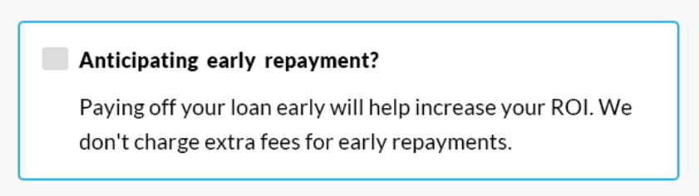

Coarse：

Fontsize:18px Fontfamily: Lato Black Color: # 000000

Thin：

Fontsize:19px Fontfamily: Lato Regular Color: # 000000

Block：

Color: # dcdcdc

Frame：

Color: # 32b5e5

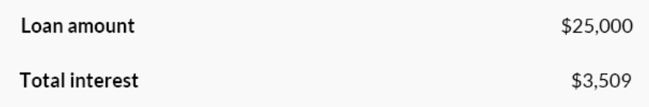

Letter：

Fontsize:18px Fontfamily: Lato Bold Color: # 000000

Number：

Fontsize:18px Fontfamily: Lato Regular Color: # 000000

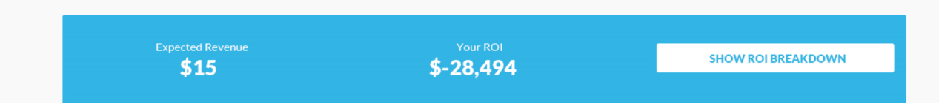

Letter white：

Fontsize:16px Fontfamily: Lato Regular Color: # ffffff background: # 32b5e5

Letter blue：

Fontsize:16px Fontfamily: Lato Black Color: # 32b5e5

Price:

Fontsize:30px Fontfamily: Lato Black Color: # ffffff

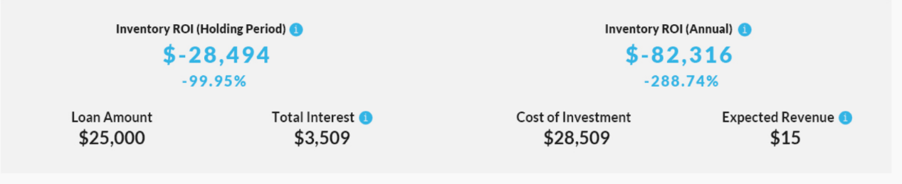

Letter（first line）：

Fontsize:16px Fontfamily: Lato Black Color: # 1c1c1c

Letter（Second elements）：

Fontsize:18px Fontfamily: Lato Bold Color: # 1c1c1c

Price blue:

（Coarse ）Fontsize:30px Fontfamily: Lato Black Color: # 32b5e5

（Thin）Fontsize:20px Fontfamily: Lato Black Color: # 32b5e5

Price black：

Fontsize:24px Fontfamily: Lato Bold Color: # 1c1c1c